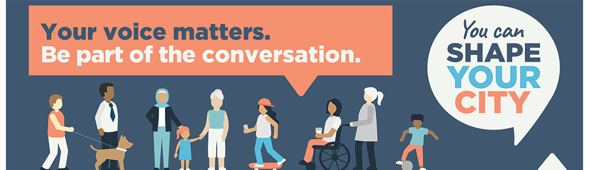

USE THIS FORM IF YOU NEED TO SAVE A FILE AND FILL IT IN BEFORE SENDING IT BACK TO US

SEND TO: communityengagement@casey.vic.gov.au

ABOUT CASEY GENERALLY

- Thinking ahead ten years, to 2030, what is one sentence that you would like to be able to use to describe the place you live and why is that important to you?

- What are some things that make you feel less connected to the place you live or that you think are not working and what can Casey do to solve that challenge?

- What would give you more confidence in Council as your local governing body?

WHERE WE LIVE
Your neighbourhood should be a place that makes you feel ‘at home’, safe and connected. Your neighbourhood is about your home, your local surrounds and the places where you spend your everyday life, including local parks and community facilities.

- What can we do to ensure that our neighbourhoods provide a welcoming, healthy and safe place for all members of the community, to encourage a greater sense of community and pride in our spaces?

DESTINATIONS
Destinations is about where we spend our day to day – where we go to work, or where we do our shopping and go to a dinner (not right now!). Destinations is about the activity and economic drivers that make Casey a good place to do businesses. These are the places we meet people that don't necessarily live on our street but might live in our postcode.

- What can we do to make our local centres thrive, to make them safe and attractive destinations that you want to keep coming back to, and ensure our businesses and services grow and are able to adapt to change?

- How can Casey support and facilitate local businesses/services to be resilient/ flexible to meet ever changing needs and expectations of the City?

HOW WE GET AROUND
How we get around considers the way we move through our streets to get from one place to another by either public transport, private vehicle (including car-pooling), or active modes of transport (such as walking or cycling). This includes travelling to work, education, or the shops.

- In what ways could transport be made more accessible and affordable for everyone in the City of Casey?​

- How could Casey support more active modes of getting around such as walking or cycling?

LOOKING AFTER THE PLACE
Looking after the place is about creating a sustainable, healthy, and pleasant environment that we can proudly pass on to our children and future generations.

- What can we do to ensure we have a clean, well-maintained and safe environment for our rapidly growing Casey population?​

- How can we better prepare for more frequent extreme weather events, such as severe storms and bushfires over the coming years and decades?

